JCC 2510

**OVERALL VIEW of moving forward ONLINE**

* Our goal for the next three weeks will be to complete our novel **Au Revoir L’Acadie**. In doing so, we will practice our reading and writing skills. To fulfill our interpersonal, we will ZOOM each Friday at

11:00 AM- 12:0 PM (to review questions from assigned chapters , interact in the target language, and touch base). We can certainly ZOOM more regularly (daily if you wish) just let me know?

* Please con’t to make predictions and summarize the chapters as we go on grid sheets. I have provided a new grid sheet on my website on which you can record items digitally.
* We will complete two to three chapters weekly to complete this task. These scanned chapter to read will be sent to you through your email because I could not get them to download on my webpage. You can let me know on Friday March 27th during our ZOOM meeting if the work load was too much or too little (BE HONEST)! You are all very intelligent so I have confidence in you that it will be a fair amount of work.
* You will be required to complete your second ***Talk Abroad*** before spring break –more info on that to come. You may want to start deciding with whom you would like that conversation (it must be someone different). The topic of your conversation will be supported by the themes from our book about (which we will be speaking during the next few weeks.) Here is the topic from our syllabus for your next Talk Abroad if you have forgotten:

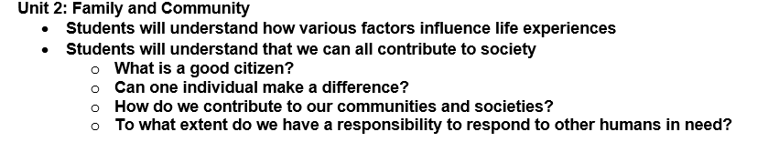

* Lastly, I will be creating a weekly agenda and questions that you need to complete online to send back to me.
* On Fridays we will have a ZOOM meeting. I will send you a link thru email in order for you to connect. You need to click on the link, type in the code that I provide and click yes to all the preliminary questions. You will then arrive to a group facetime.

This is the plan up until spring break. We will regroup after that depending on if we are back to school or not.

Follow my webpage for all work items and don’t hesitate to email me with questions. I will be answering mostly in the AM and after dinner hours.